ONLINE SHOPPING PROJECT DOCUMENTATION

Project Members

Ajay Gannamaneni

Kirti Pawar

Saloni Jindal

Pranav Menon

SCRUM BOARD DAY 1

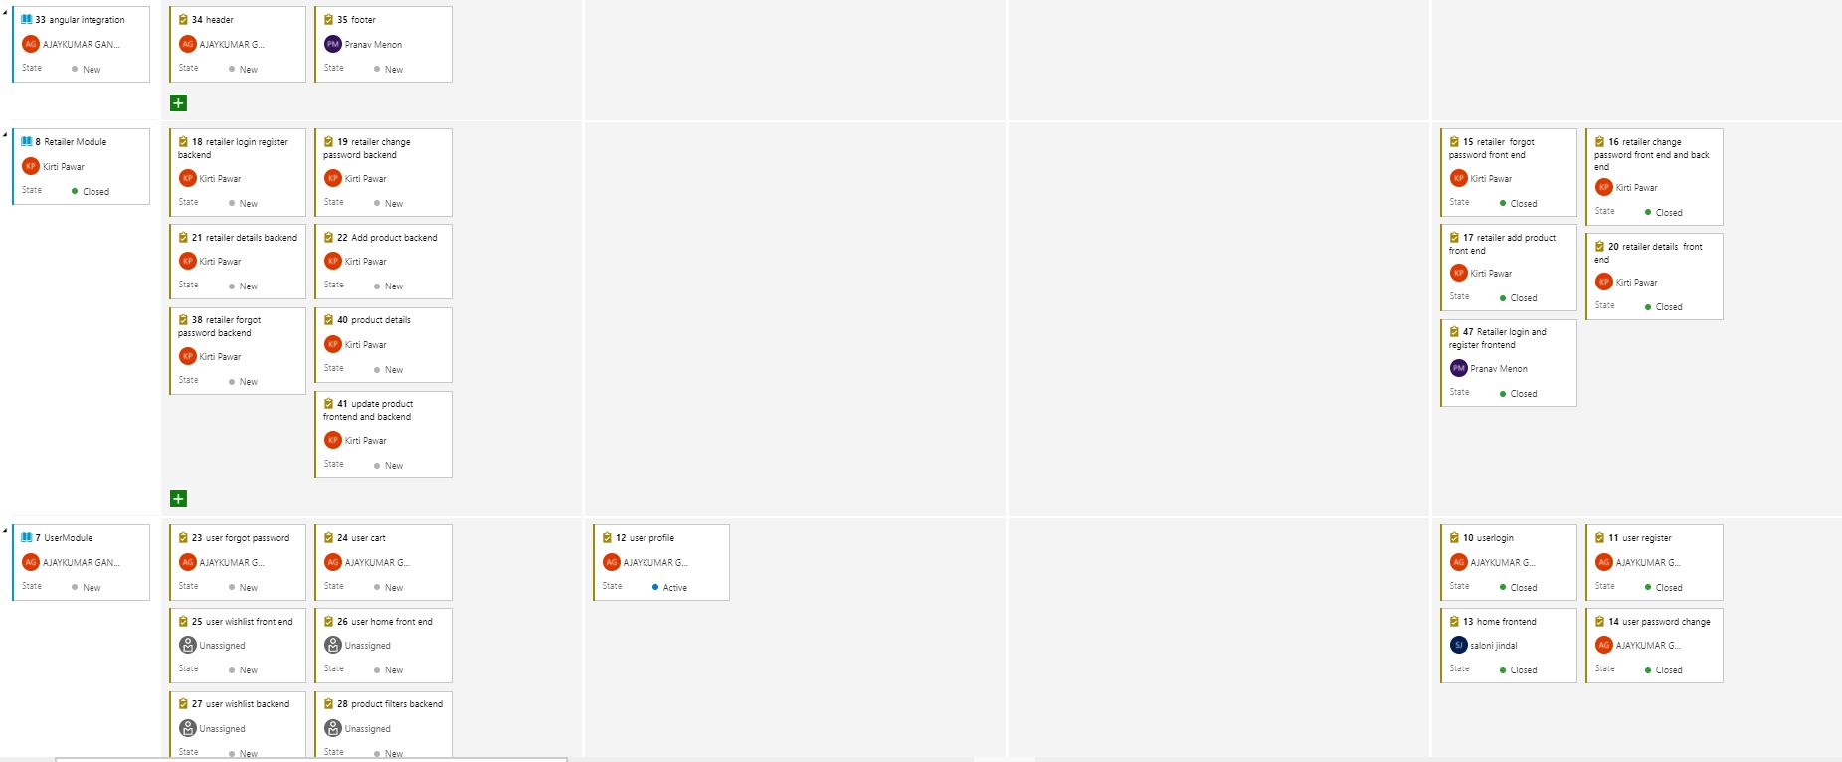 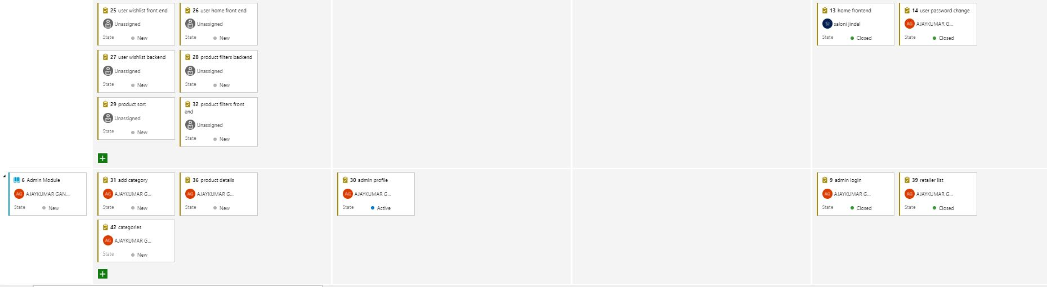

SCRUM BOARD DAY 2

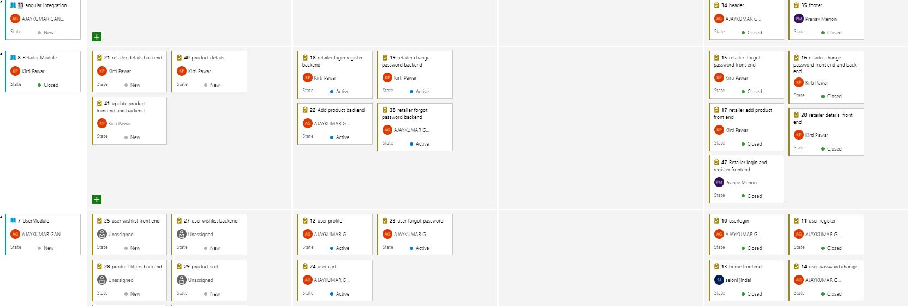 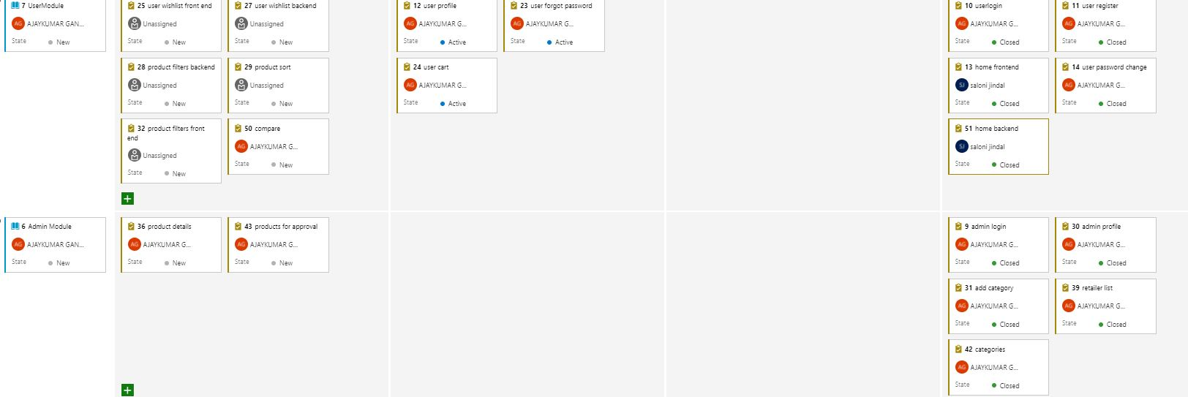

SCRUM BOARD DAY 3

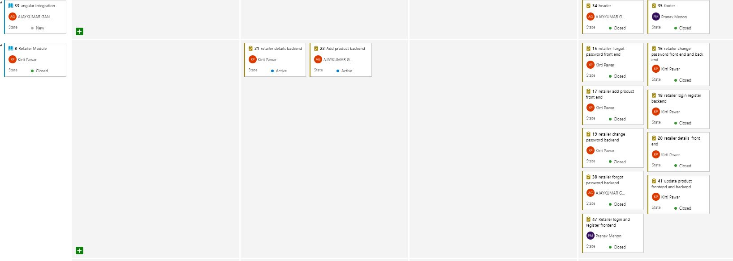 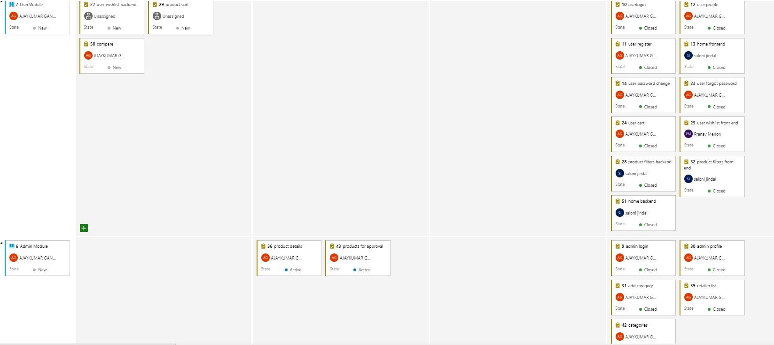

SCRUM BOARD DAY 4

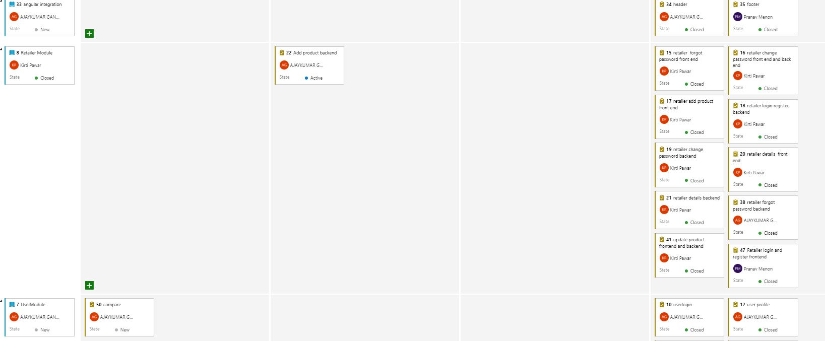 

FINAL SCRUM  

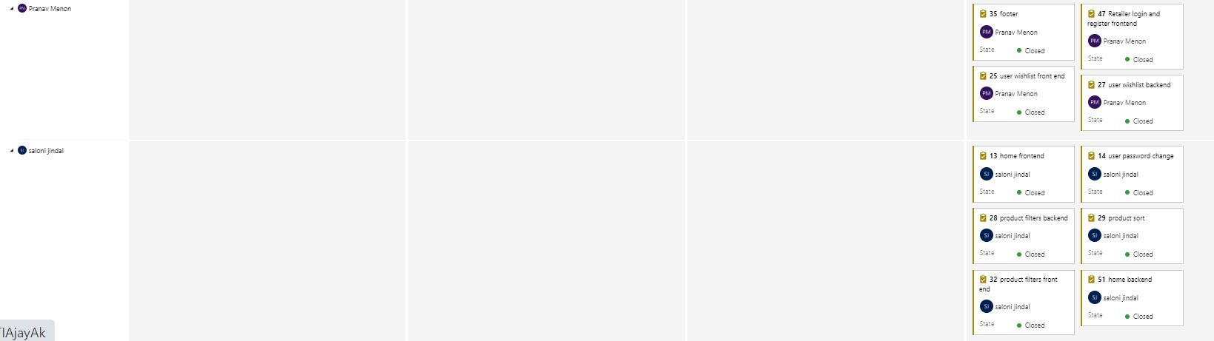

THANK YOU